# Google

Story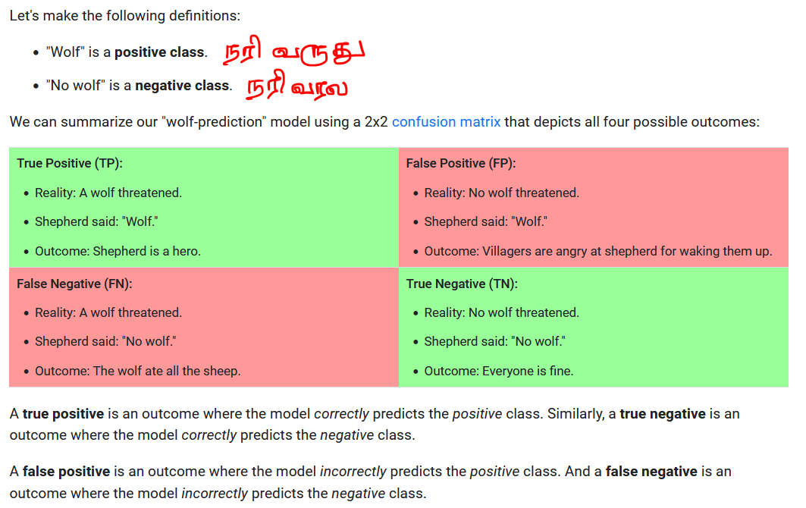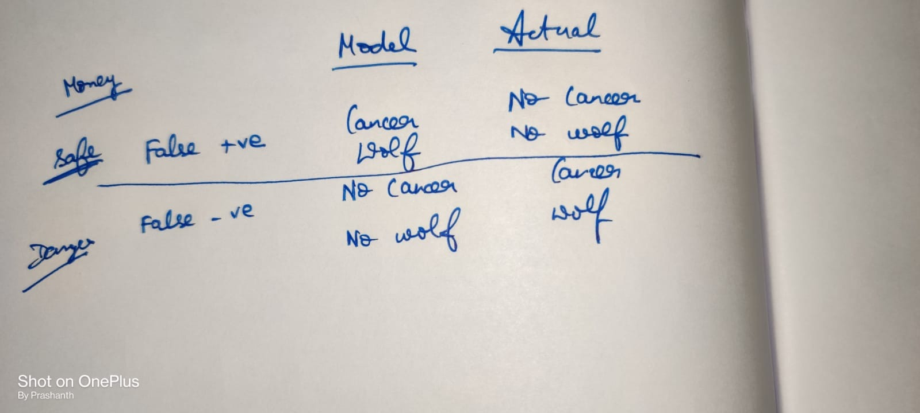

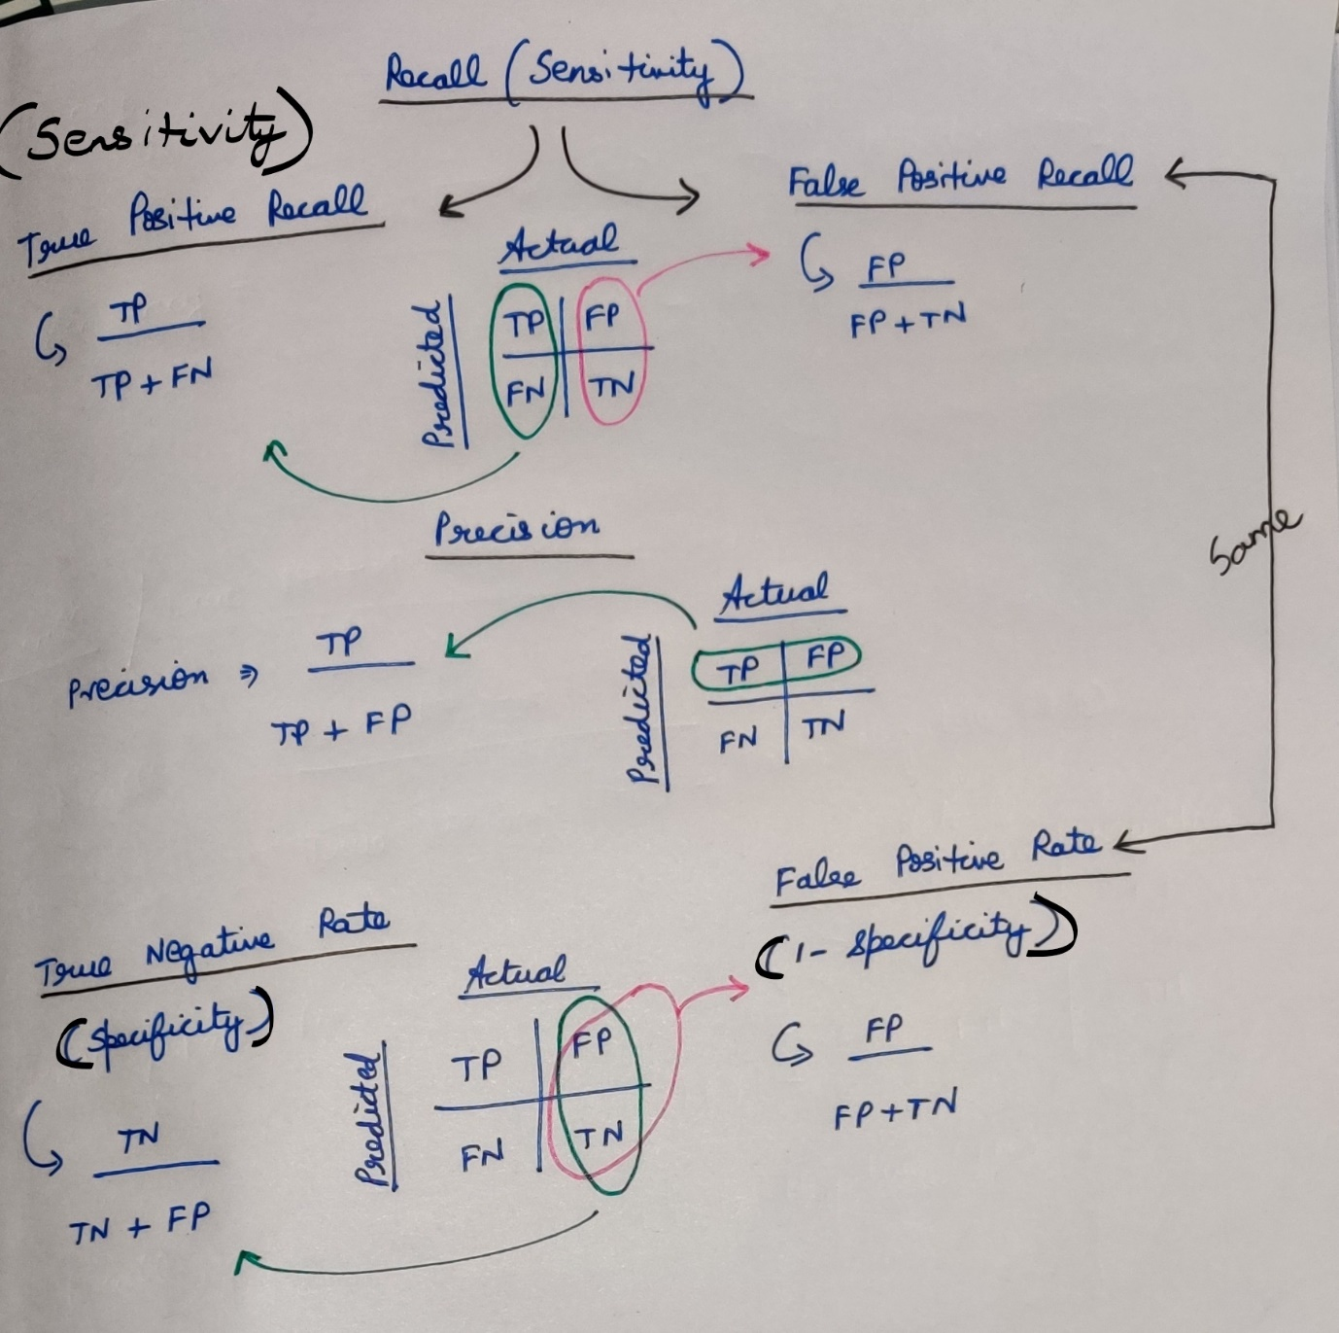

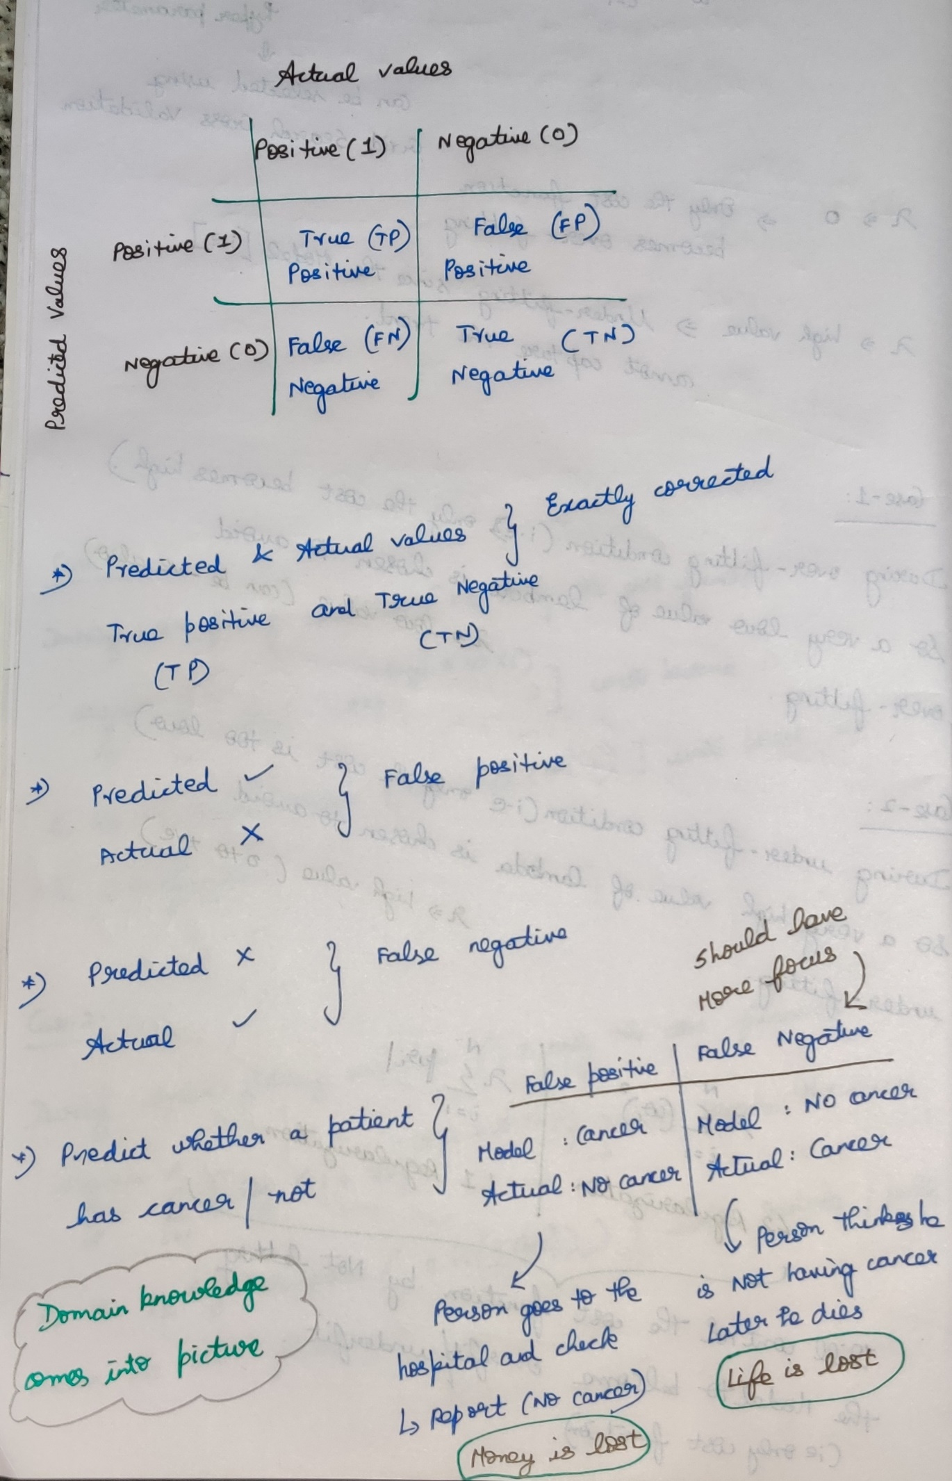

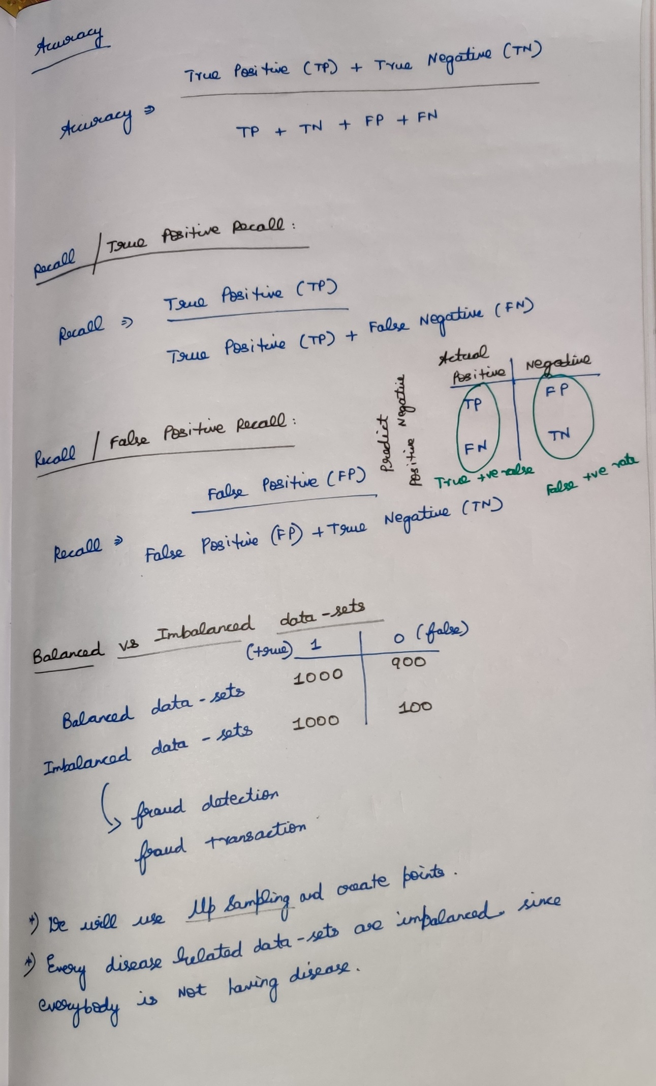

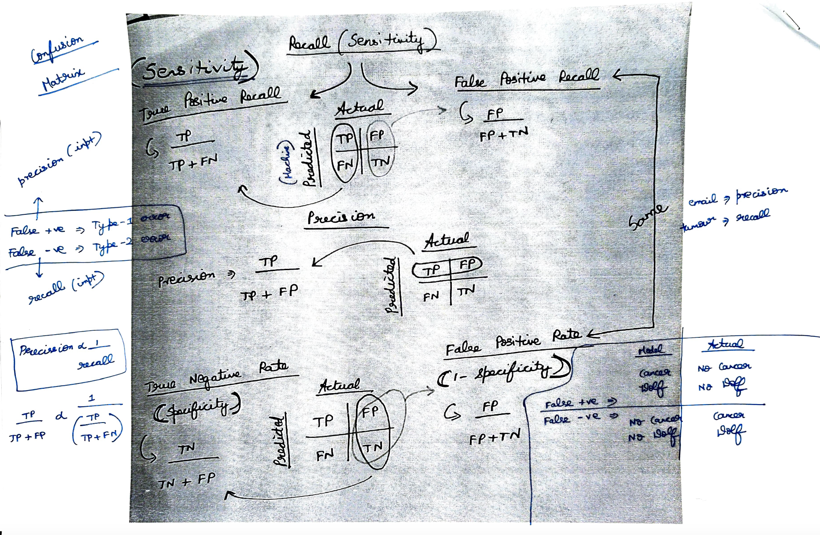

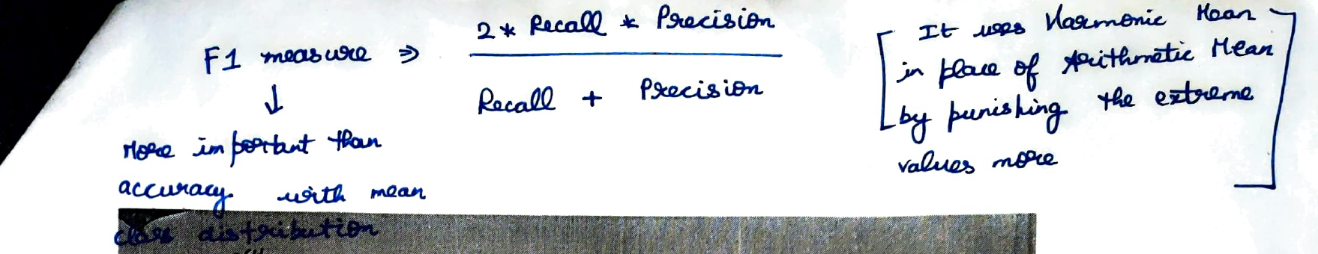

**Statistical Power**Statistical power, or the power of a hypothesis test is the probability that the test correctly rejects the null hypothesis.  
More intuitively, the statistical power can be thought of as the probability of accepting an alternative hypothesis, when the alternative hypothesis is true.

# **True Negative**

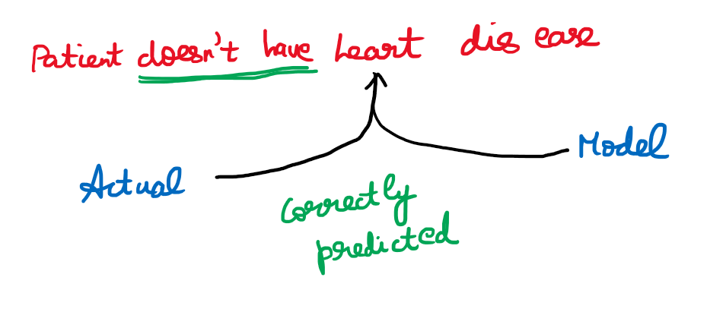

# **False Negative**

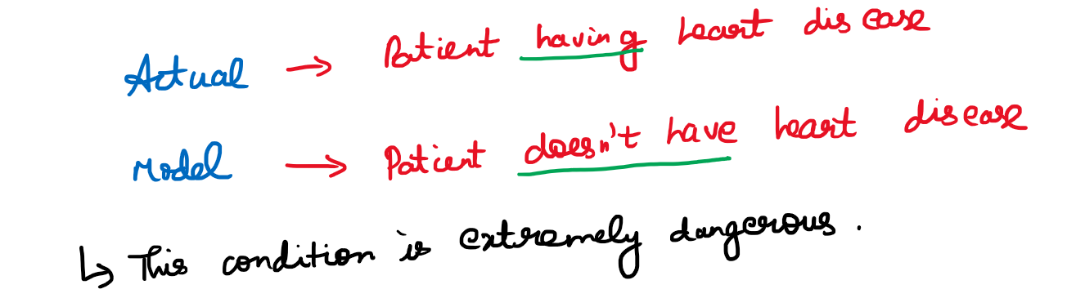

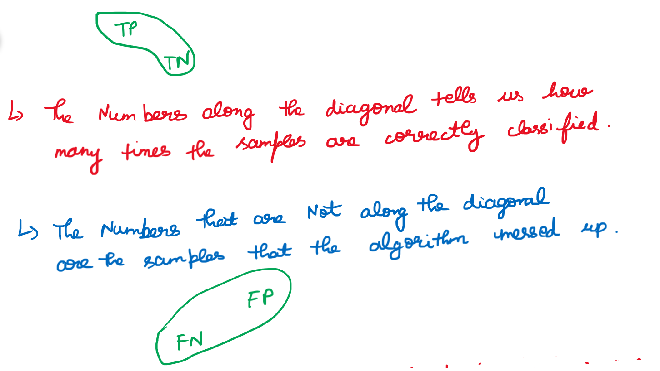

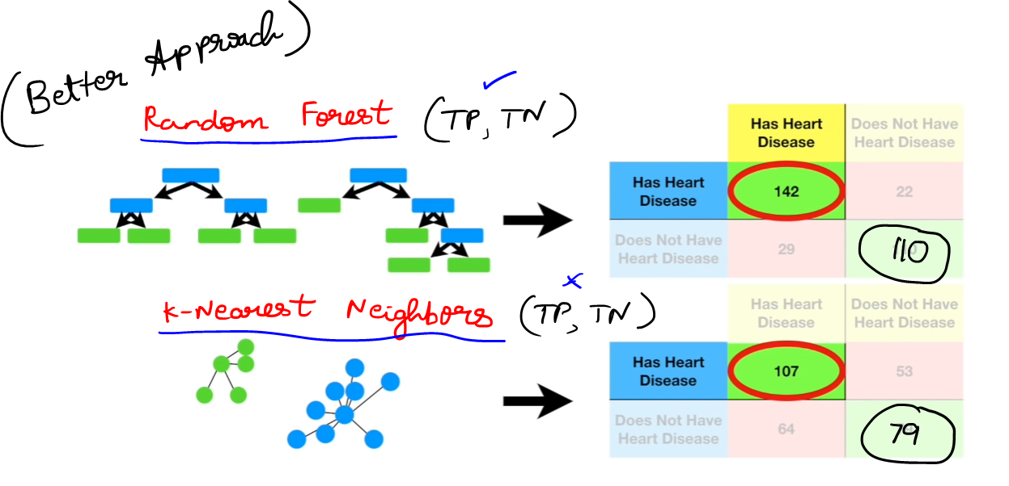

# **Sensitivity**

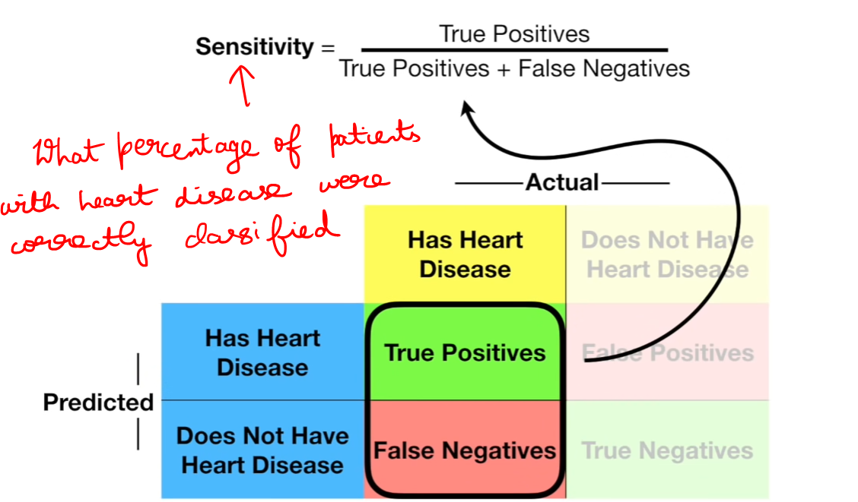

# **Specificity**

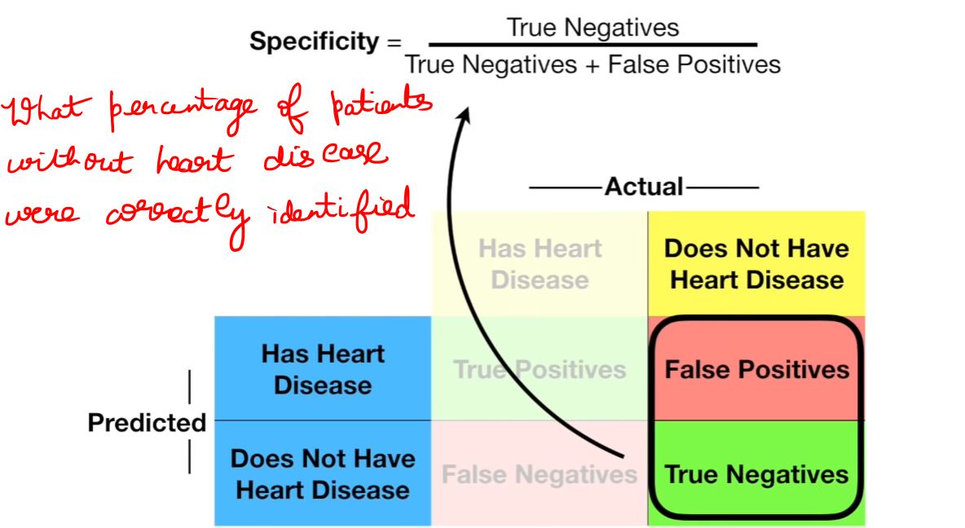

## **Logistic Regression**

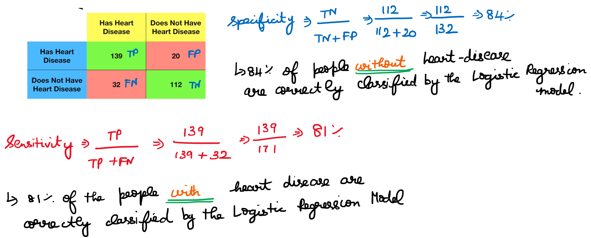

## **Random Forest**

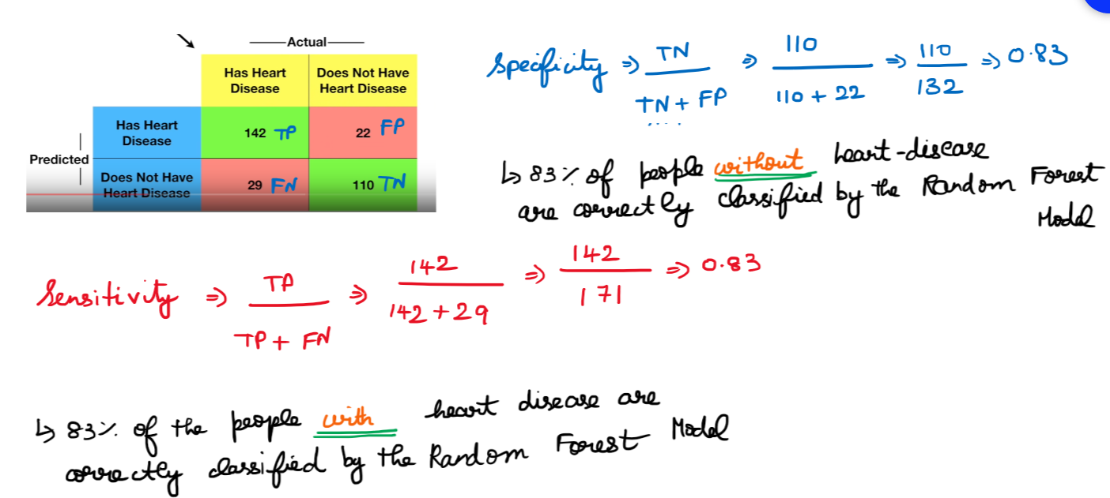

# **Comparing both the confusion matrices**

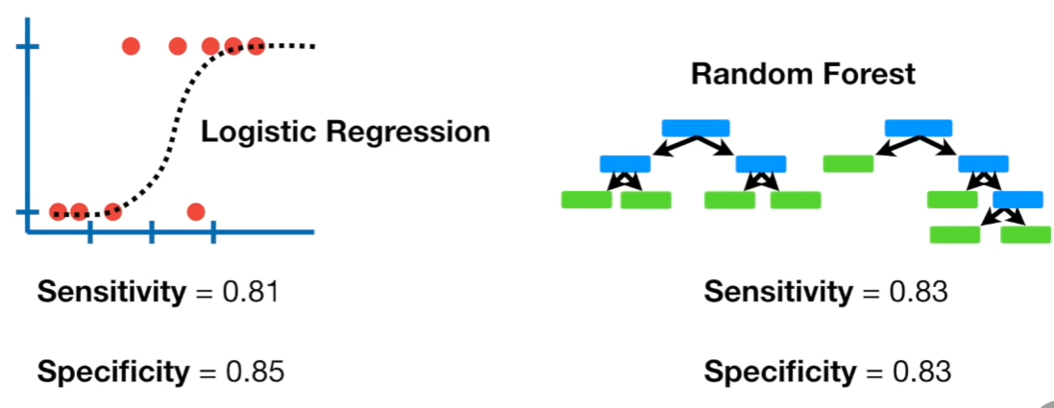

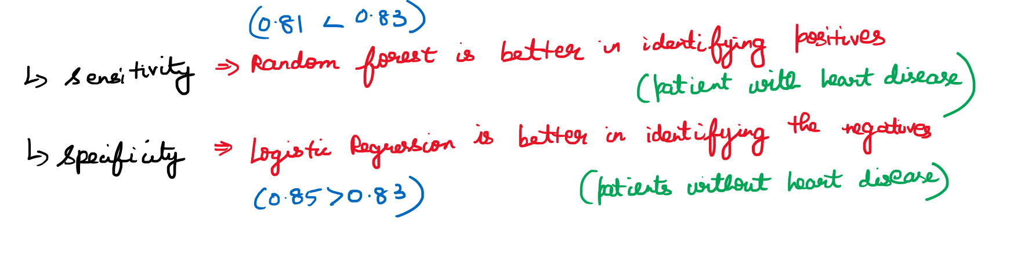

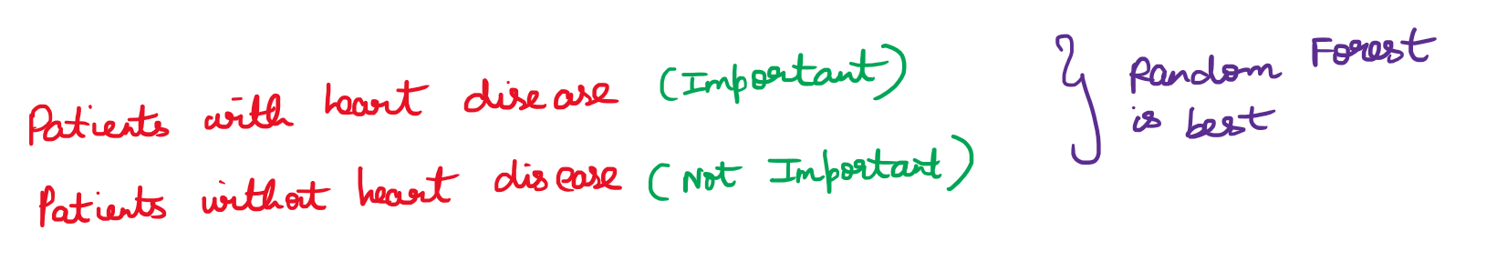



# **Final thoughts**

Spam mail detection 🡪 False Positive   
Medical 🡪 False Negative

<https://developers.google.com/machine-learning/crash-course/classification/true-false-positive-negative>